**SMTP**

SMTP is part of the application layer of the TCP/IP protocol. Using a process called "store and forward," SMTP moves your email on and across networks. It works closely with something called the Mail Transfer Agent (MTA) to send your communication to the right computer and email inbox.

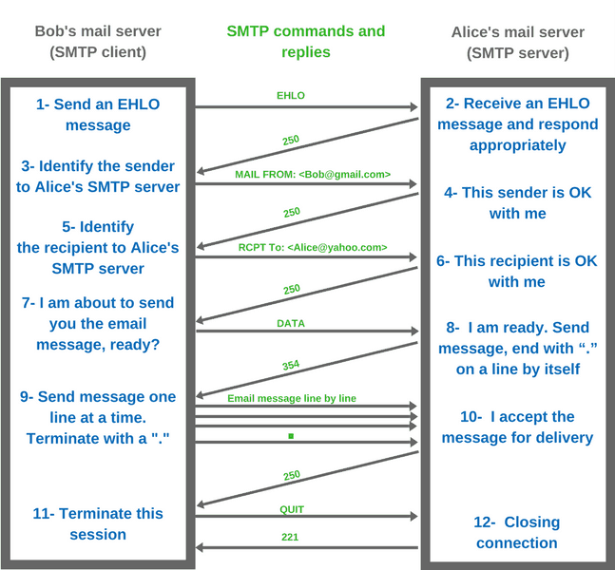

The user is using the loopback IP address of 127.0.0.1 to communicate to a SMTP server running on the local machine.

The user logged into the server and sent an email to himself.

All data was transmitted to the server on port 25, which is reserved for SMTP communication. The user received his data back on port 7041.